How to enable VVDI Mini Key Tool Free ID48 96bit Copy?

Every vvdi mini Key tool inc free copy 48 96bit 1/day (1 year)

How to enable:
1) Turn on Bluetooth , make sure Mini Keytool is power up
2) Login APP and detect device , when recognize, tap to connect
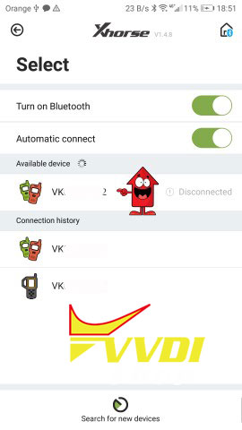
2) After success connection your device will be display in APP
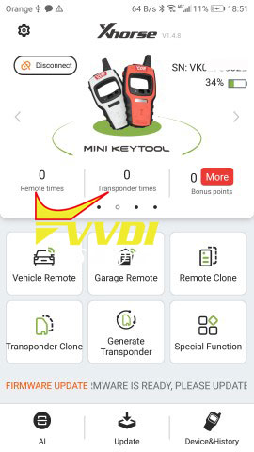
3)Bottom right corner click Device & History to see available license
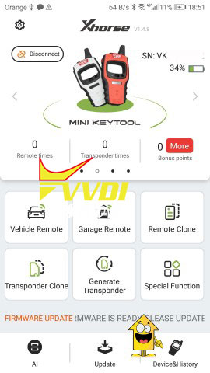
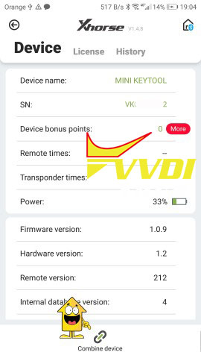
4) to Activate 48 96bit Go to Device Page bottom right - Device & history
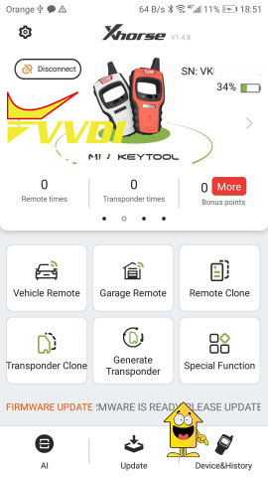
5) Next click Combine Device
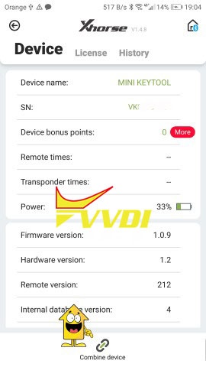
6) Require Security code and write it within 60sec after request (will be send via TXT message)
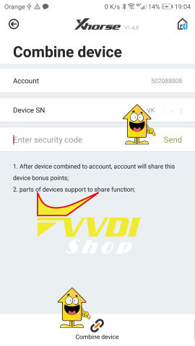
7) After you receive Security code - click Combine Device at the bottom page
8) After success connection your device will be display
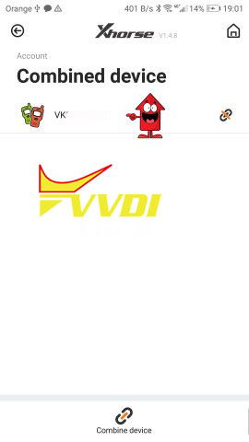
9) go to main page - click SHOP
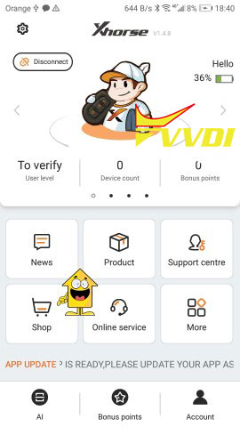
10) Find MiniKeytool Activation and mark activation and click EXCHANGE
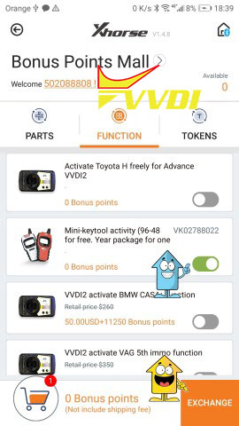
11) Check device number and click OK
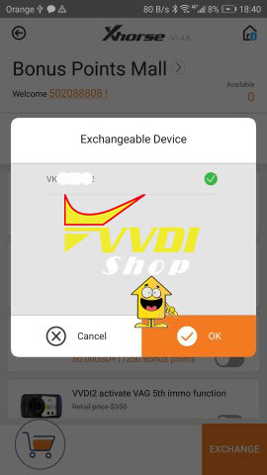
12) Next page require to provide your address and Dealer location
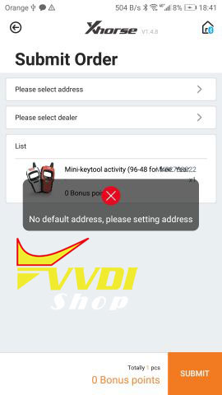
13) Click SUBMIT when you finish
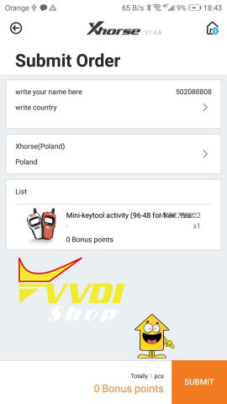
14) Activation is enabled and can be used
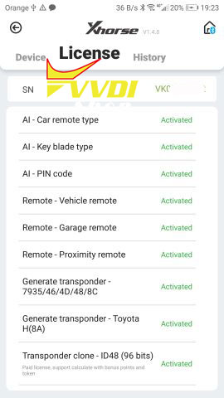
www.vvdishop.com

